GLP (Global Logistic Properties) Valuation Report

# Company Overview

GLP (Global Logistic Properties) is a leading global business builder, investor, developer, and operator of logistics, digital infrastructure, renewable energy, and related technologies. As of 31 December 2023, GLP owned, managed, and leased an extensive network of approximately 3,300 completed properties across 293 cities and 17 countries, including China, Japan, U.S., Europe, Brazil, India, and Vietnam, with a combined GFA and GLA of approximately 64.8 million square meters. The Group also had interest...  
  
GLP's strategic focus on high-growth, new economy investment themes, including logistics, digital infrastructure, and energy transition, supports its long-term growth and success.

# Business Segments

GLP's business is segmented into three main areas:  
  
1. **Logistics**: Core pillar of the business, involving investment, development, and operation of logistics real estate and technologies globally. GLP has a network of over 3,300 properties with a GFA of 64.8 million sqm.  
  
2. **Digital Infrastructure**: Serving the digital infrastructure needs of hyperscale companies and large global enterprises, with assets of over 2 GW IT capacity across APAC, Europe, and the Americas.  
  
3. **Energy Transition**: Focusing on renewable energy development with more than 890 MW of installed renewable energy capacity globally. The segment includes distributed and ground-mounted solar, wind, and battery storage solutions.

# Geographic Distribution

GLP operates in 17 countries, with significant presence in key markets including:  
  
- China  
- Japan  
- United States  
- Europe  
- Brazil  
- India  
- Vietnam  
  
Each region's strategic locations within key metropolitan areas enable GLP to provide optimal solutions for its customers and drive synergies across its global network.

# Fundamental Analysis

Key Fundamentals:  
1. Revenue Growth: Steady increase in revenue over the years, driven by rental income, management fees, and expanding services.  
2. Profitability: Positive net profit, though fluctuating, indicating the company's ability to generate earnings.  
3. Asset Base: Significant total assets with a substantial portion in investment properties and equity accounted investments.  
4. Equity: Consistent equity levels, highlighting strong financial health.  
5. Cash Flow: Positive net cash from operating activities, although variability in investing and financing activities.  
  
Key Drivers:  
1. Market Expansion: Growth in logistics real estate, digital infrastructure, and renewable energy sectors.  
2. Strategic Investments: Investments in high-growth sectors and key geographic regions.  
3. Fund Management: Significant AUM through GLP Capital Partners, providing stable revenue streams.  
4. Technological Integration: Adoption of digital technologies for operational efficiency.  
5. Sustainability: Focus on ESG initiatives and renewable energy projects.

# Financial Highlights

Key Financial Metrics (in USD thousands):  
- Revenue: 2021: 1,634,188 | 2022: 1,910,673 | 2023: 2,431,127  
- Net Profit: 2021: 1,686,037 | 2022: 534,020 | 2023: 233,280  
- Total Assets: 2021: 44,734,055 | 2022: 51,048,101 | 2023: 43,763,247  
- Equity: 2021: 24,312,634 | 2022: 24,708,764 | 2023: 21,207,607  
  
The financial performance shows steady revenue growth, although net profit has fluctuated over the years. The company's asset base remains significant, highlighting its financial health.

# Bond Recommendations and Valuation

We initiate coverage of GLP Pte (ticker: GLPSP) which has three public USD bonds totaling USD2.15bn and its subsidiary GLP China (ticker: GLPCHI) with one bond (USD700mn outstanding). Liquidity pressure has eased after repayment of concentrated maturing bonds in 1Q24 (cUSD1.4bn). Looking ahead we expect GLP to maintain good banking relationships and to see improving credit quality with higher recurring EBITDA, ongoing asset sales/fund interest divestments, and scaled-back capex. On the other hand, we see...  
  
Thus, we initiate coverage of GLPSP'25/GLPCHI'26/GLPSP 4.5% PerpC'26/GLPSP 4.6% PerpC'27 at Overweight. Risks are delays in asset divestment and proceeds collection, loss of major tenants, deterioration of relationship with banks and logistics investors, and significantly higher related-party transactions.

# Liquidity Analysis

GLP's credit quality had deteriorated over recent years due to (1) delays in executing its asset-monetization strategy and (2) its use of the majority of sale proceeds to fund business expansion and material related-party transactions with Bidco. Looking ahead, we expect GLP to see higher recurring EBITDA with a stable lease ratio and rising fund AUM. We also expect GLP to reduce its capex and sell assets/divest stakes in funds (USD3-4bn proceeds in 2024). We view GLP's well-located properties and demand from Chinese investors, such as insurers, to likely provide headroom for asset sales and fund syndication, although success would depend on management's commitment and execution.

# Credit Rating

GLP Pte is rated BB/Stable by Fitch currently. The rating agency downgraded GLP by two notches from BBB- to BB in October 2023 due to the company's deteriorating credit ratios such as net debt/recurring EBITDA (including dividends from jointly controlled entities) and recurring EBITDA/cash interest. Separately, S&P lowered the rating of GLP/GLP China by two notches from BBB- to BB, placed the outlook at Negative in November 2023, and withdrew the ratings subsequently at GLP's request. The downgrade was due to waning earnings quality and weakening liquidity positions as a result of delays in asset monetization.  
  
GLP China does not have ratings from Moody's, S&P, and Fitch. It is rated AAA/Stable by both China Chengxin and Shanghai Brilliance Credit Ratings. With the eased liquidity pressure at the GLP China level, we think that the risk of negative rating actions has materially reduced now.

# Other Key Items

Potential deal with China Logistics Group: Bloomberg reported in July 2023 that GLP China was in talks with China Logistic Group (CLG) regarding selling some of its assets in China (GLP has confirmed). CLG is 77.8% owned by SASAC (State-owned Assets Supervision and Administration Commission of the State Council) directly (38.9%) and indirectly via wholly owned entity China Chengtong. GLP has made c.USD7bn worth of assets in China available for CLG to choose from. Due diligence was completed by September.  
  
Potential IPO of GCP: Redd reported that GCP, which managed around USD128bn of GLP's assets by December 2023, may seek an Initial public offering (IPO) in the US in 2024. According to the report, GCP intends to use some of the proceeds from the potential IPO to repay debt payable to GLP China (USD1.3bn by June 2023). Previously, in March 2022, Bloomberg reported that GLP had filed confidentially to list its investment business in the US as soon as 1H22. According to the report, GLP was seeking to raise about USD2bn and AUM was about USD120mn at that time. However, rising interest rates and equity market volatility amid geopolitical tensions reportedly caused the potential IPO to be delayed. GLP has not commented on these reports.

# Charts and Graphs

## Revenue Growth

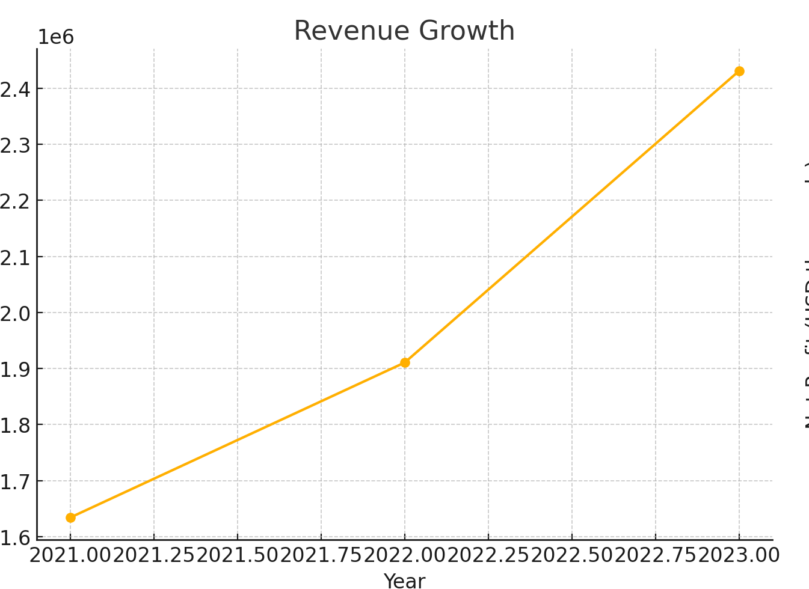

## Net Profit

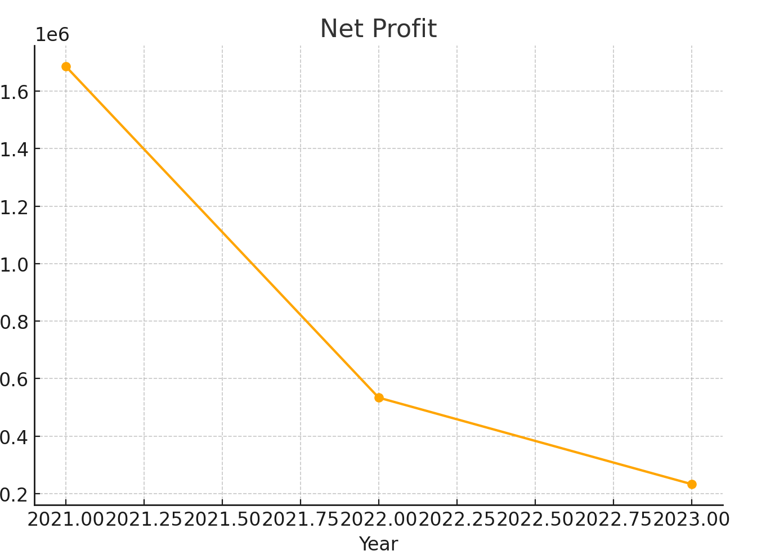

## Total Assets vs Total Liabilities

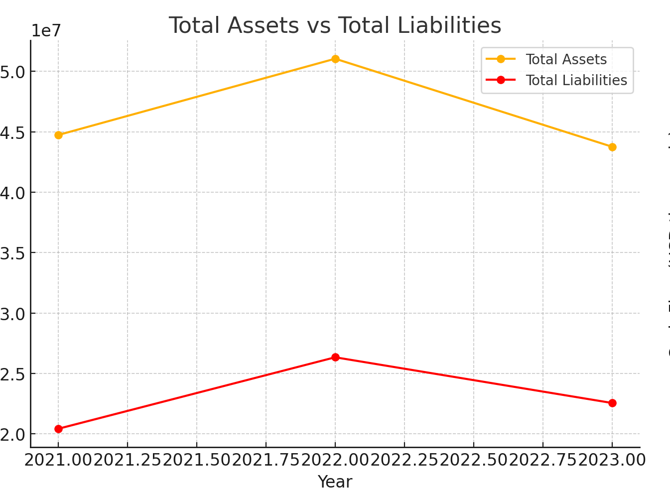

## Cash Flow Activities

